***Things You need to remember before attempting exam of EM :***

* **Probability** :
* **Linear Algebra** :

1. Decomposition of determinant :

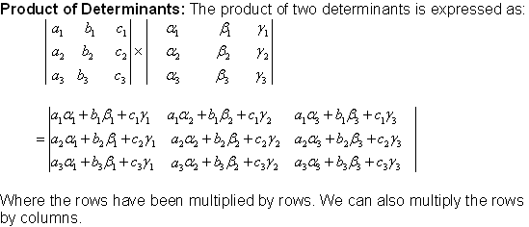🡨 reverse of this is also important

1. A system of linear equations having matrix form AX = O, where O represents a zero-column matrix, is called a homogeneous system.
2. If rank of matrix is n-1 then it is **not** necessary that one row of matrix must be zero. Example 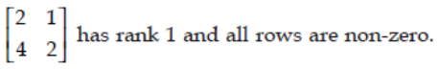
3. Linearly dependent means determinant is zero.
4. Cij = (-1)i+j Mij, where Mij is minor of aij.
5. 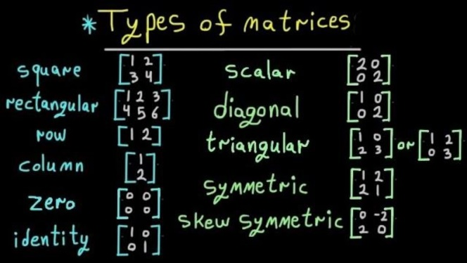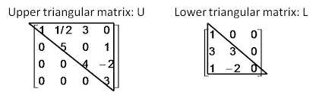
6. 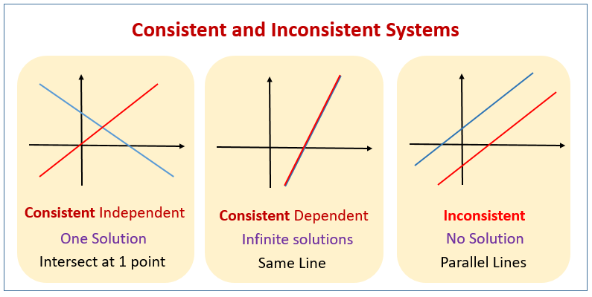

Inconsistent means two or more lines are parallel that’s it.

1. Idempotent matrix is matrix A such that An = A.
2. 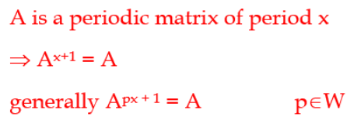
3. Ax=λx. Multiplying both sides by A, we get LHS=AAx=λAx=λ(Ax)=λ(λx)= λ2x. LHS = RHS. λ2= λ. Lemdah = 0 or 1. Which means matrix is idempotent if and only if its eigen values are either one or zero.
4. 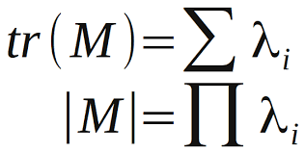,Where lambda is eigen values.
5. 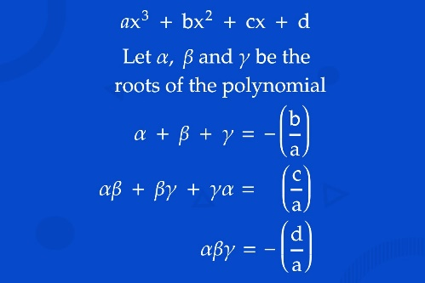🡨 plz apply this whenever you came across cubic equation don’t afraid.
6. Eigen vector (A) = Eigen vector(A-1)
7. If matrix is **real** then eigen values of A and AT is same.
8. Det(Adj A) = |A|n-1, and det(adj(adj(…m times A))) = |A|(n-1)^m, Where n is order of matrix A.

Adj(Adj…m times of A))… = |A|(n-m)A.

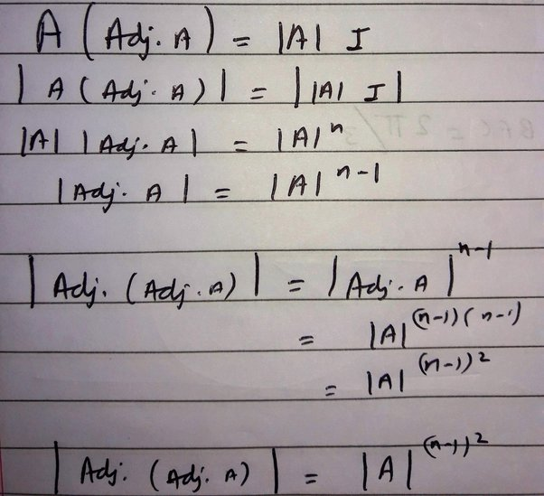

1. 
2. If all eigen values are distinct and order of matrix is n then we have n independent eigenvectors. This is too simple.
3. A pivot position in a matrix is the location of a leading entry in the row-echelon form of a matrix.
4. **Relation between rank of matrix and eigen value of a matrix** :

* If a matrix has 1 eigenvalue as zero, the dimension of its kernel may be 1 or more (depends upon the number of other eigenvalues).
* If it has n distinct eigenvalues its rank is atleast n.
* The number of independent eigenvectors is equal to the rank of matrix.
* **Calculus** :

If function is not continuous or differentiable at some value then divide OR split that interval from that value. And again check for continuity and differentiability for two splits.

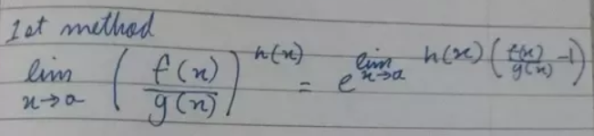

***“ The person who goes to the gym, every single day regardless of how they feel will always beat the person who goes to the gym when they feel like going to the gym. ”***

**PROBABILITY**

**Chapter 1 : Bayes Formula** :

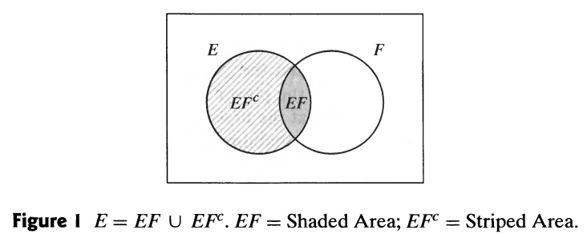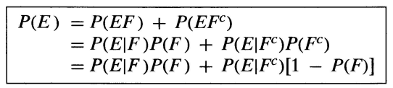(EF’ = E – EF)

Suppose that F1,F2, ... ,Fn are mutually exclusive events such that 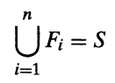. In other words, exactly one of the events F1, F2, ... , Fn must occur. By writing 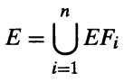

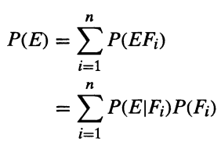 🡨 **Law of total probability**

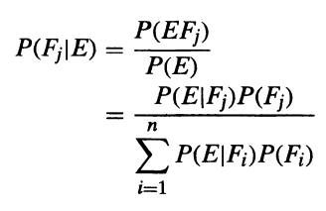🡨 **Bayes’ Theorem**

**Oddness of Event :** 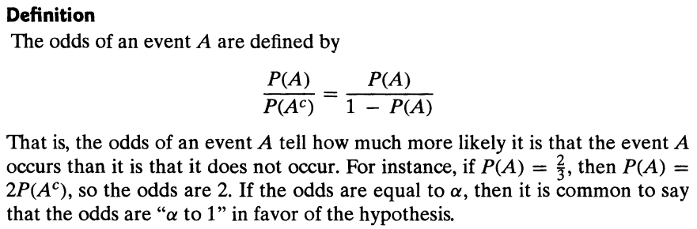

**Independent Event :** Since P(E/F) = P(EF) / P(F), it follows that E is independent of F if P(EF) = P(E)P(F)

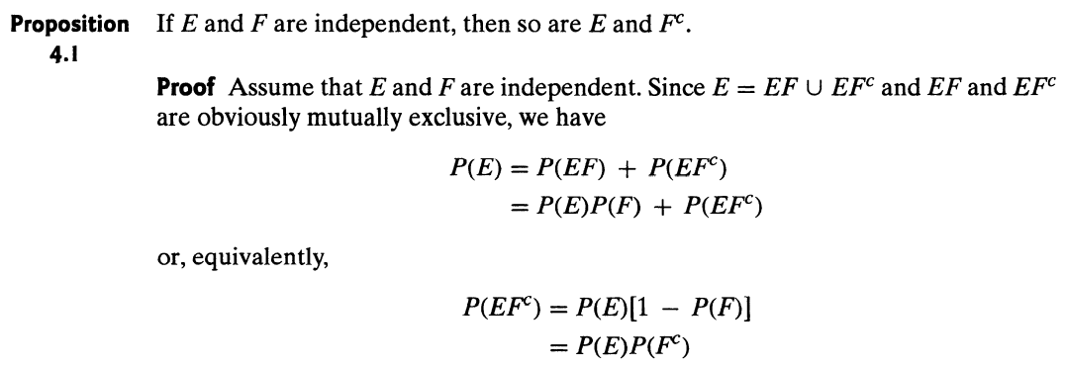

**Chapter 2 : Random variables :**

we may be interested in knowing that the sum is 7 and may not be concerned over whether the actual outcome was (1, 6), (2, 5), (3, 4), ( 4, 3), (5, 2), or (6, 1). Also, in flipping a coin, we may be interested in the total number of heads that occur and not care at all about the actual head-tail sequence that results. These quantities of interest, or, more formally, these real-valued functions defined on the sample space, are known as **random variables**.

**Discrete Random Variable** : A random variable that can take on at most a countable number of possible values is said to be discrete. For a discrete random variable X, we define the probability mass function p(a) of X by p(a) = P{X =a}

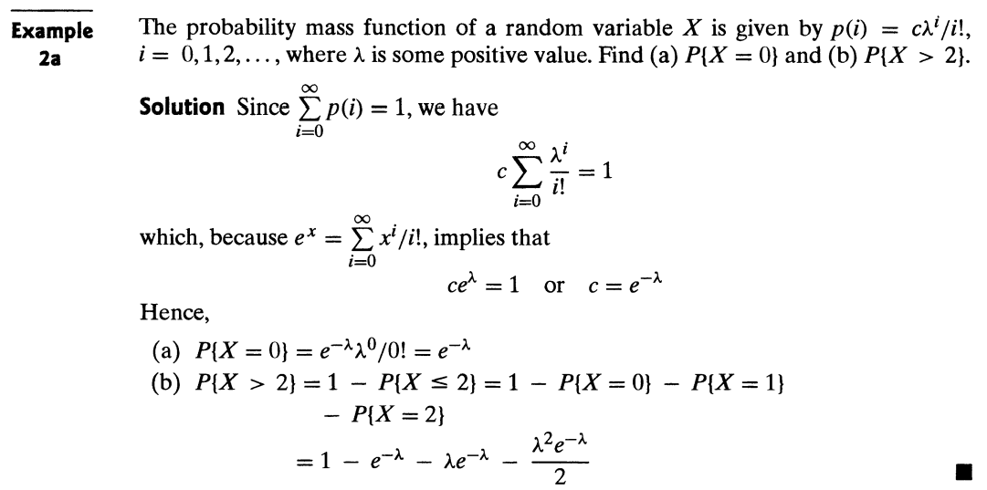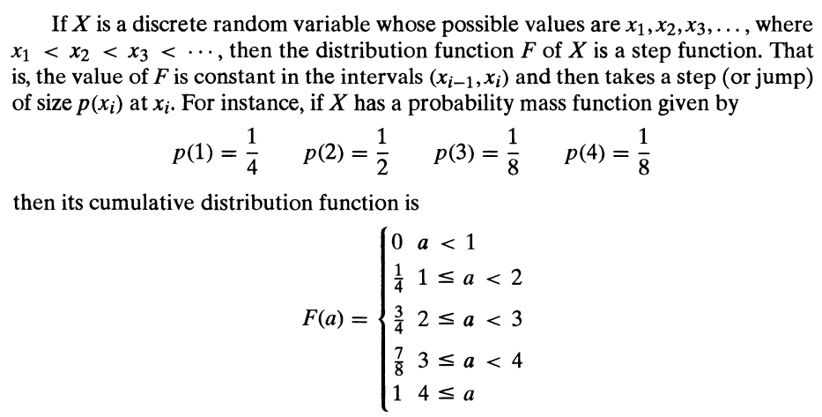

**Expected Value** : If X is a discrete random variable having a probability mass function p(x), then the expectation, or the expected value, of X, denoted by E[X], is defined by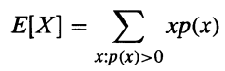

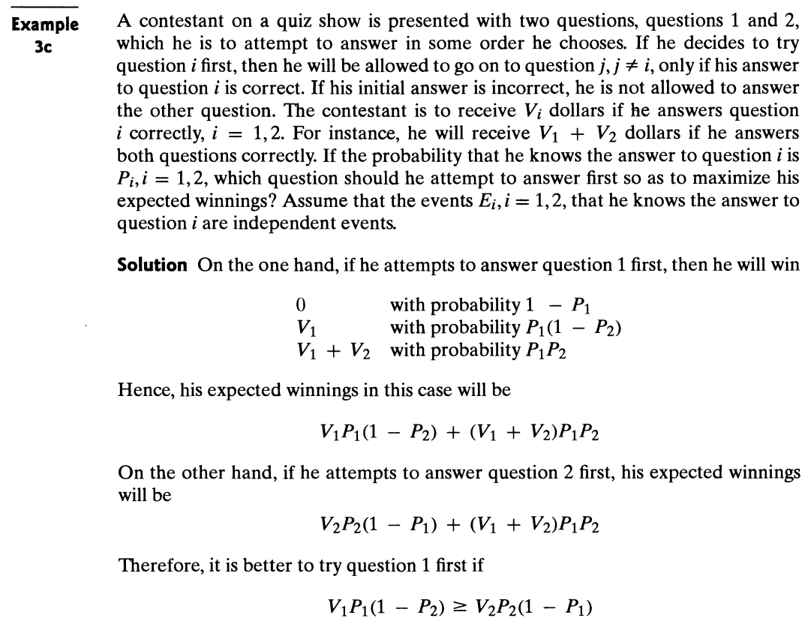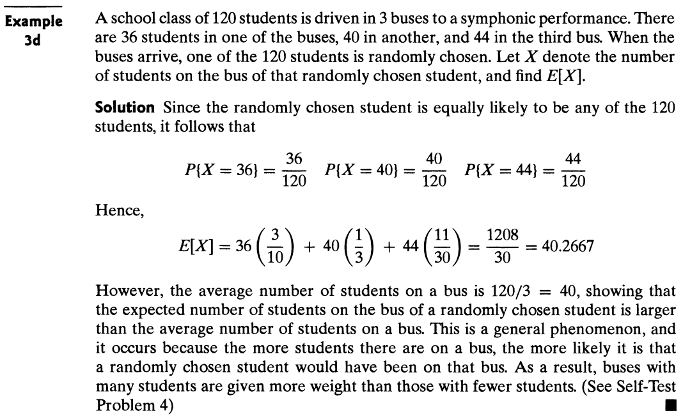

**Example on Normal random variable :**

Let Y be a Normal random variable with mean 3 and variance 4.What is P(2<Y<4)? It is given that P(Z<0.5)=0.6915 for standard normal random variable Z.

***Answer*** :

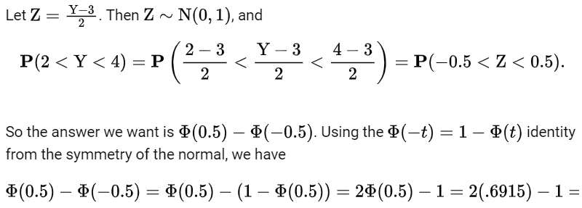

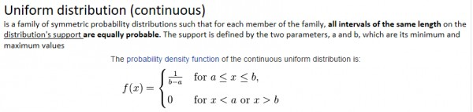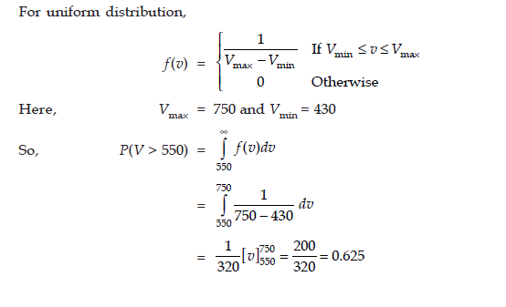

**In uniform distribution in integration as you can see upper limit and lower should be Vmax and Vmin and not infinity and -infinity.**

**Remember probability density function can’t be negative. If you get negative check twice it could be trap.**

**Expectation of a Function of a Random Variable** :

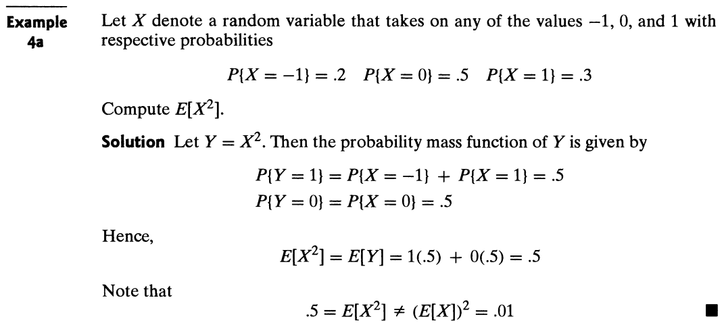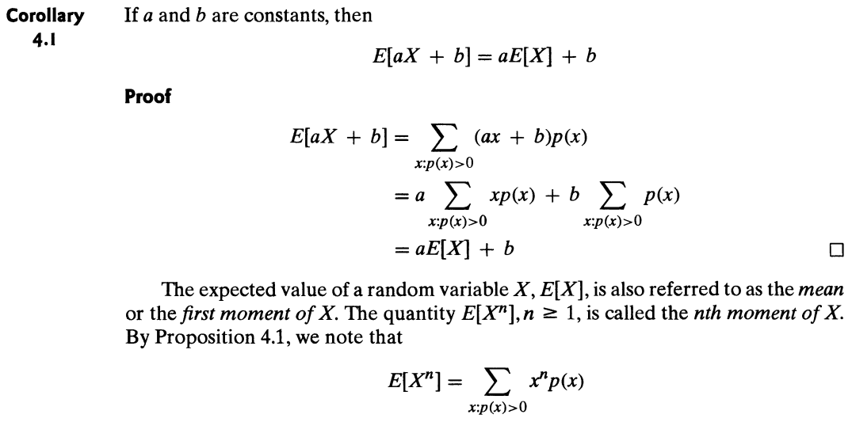

**Variance :**

Also, Var(X) = E[(X−E(X))2]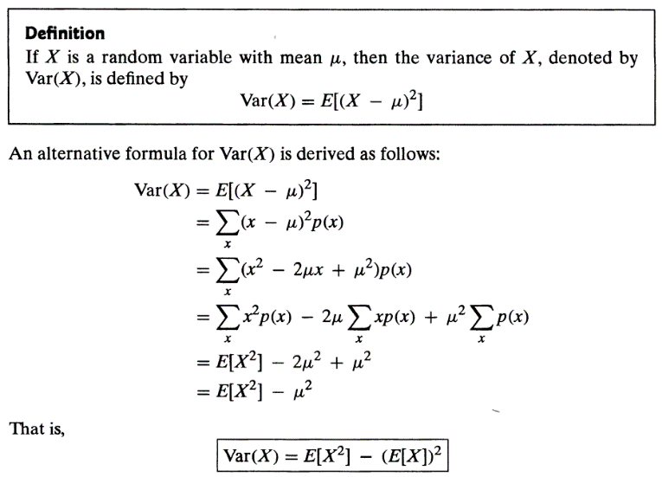

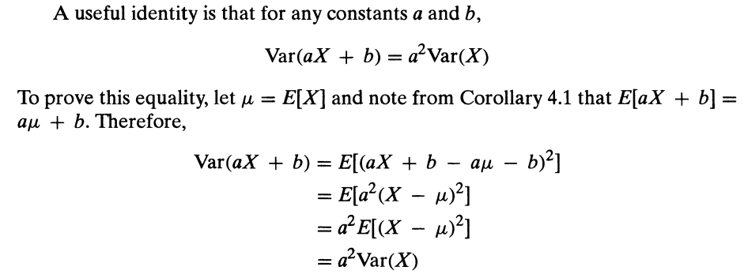

(b) The square root of the Var(X) is called the standard deviation of X, and we denote it by SD(X). That is, SD(X) = (var(X))1/2.

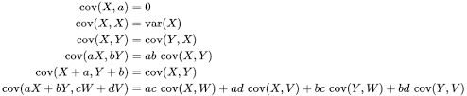

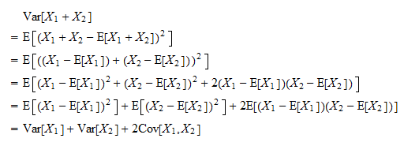

**Binomial Distribution and Binomial random variable :**

Suppose that a trial, or an experiment, whose outcome can be classified as either a success or a failure is performed. If we let X = 1 when the outcome is a success and X = 0 when it is a failure, then the probability mass function of X is given by p(0) = P{X = 0} = 1 - p

p(1) = P{X = 1} = p

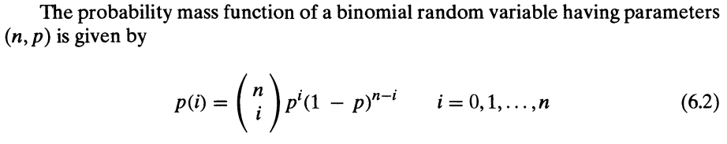

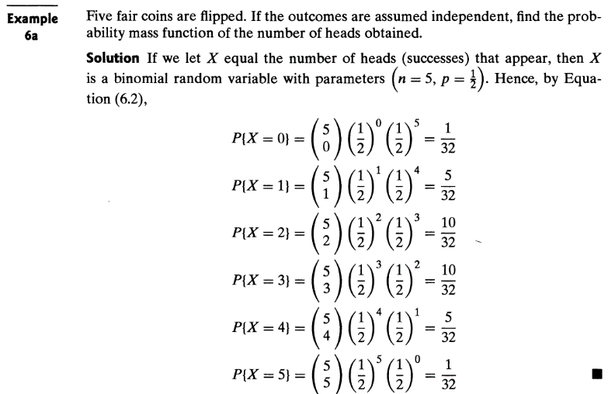**Properties of Binomial Random Variables** :

E[X] = np

E[X2] = npE[Y + 1] = np[(n + 1)p - 1]

= np[np + p - 1] = np[np+q] = (np)2 + npq

Var(X) = np(l - p), Again Var(X) = E[X2] - (E[X])2

**Computing the Binomial Distribution Function** :

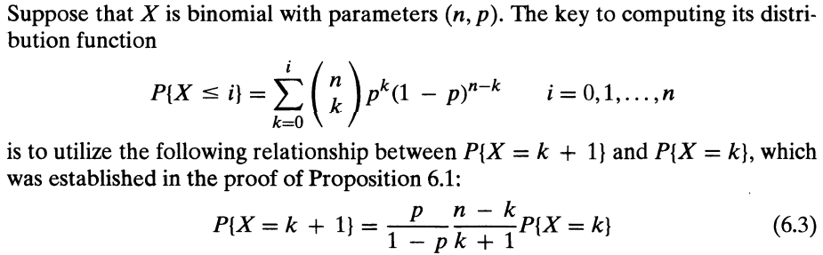

**The Poisson Random Variable** :

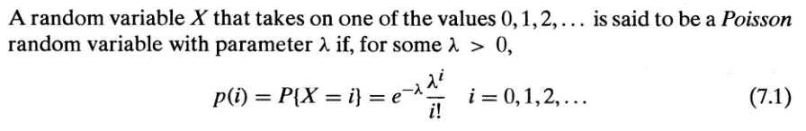In other words, if n independent trials, each of which results in a success with probability p, are performed, then when n is large and p is small enough to make np moderate, the number of successes occurring is approximately a Poisson random, variable with parameter **λ = np**.

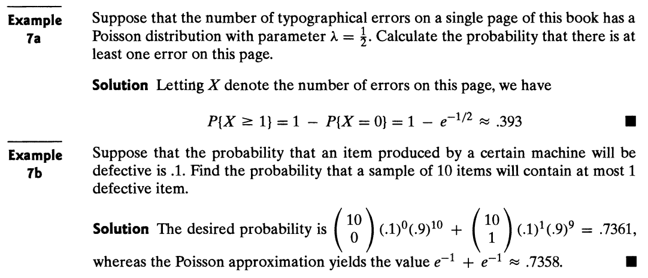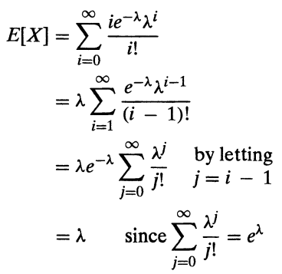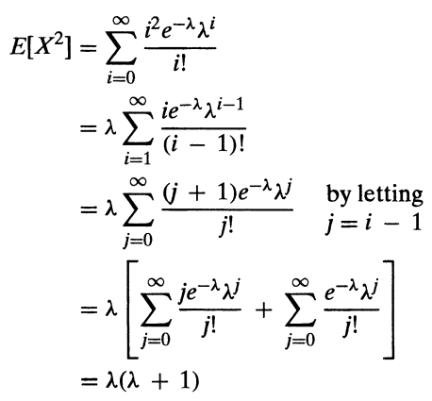

Var(X) = E[X2] - (E[X])2 = λ

**Commutative frequency** : It is the sum of probability less than or equal to random variable.

Mean mode and median :

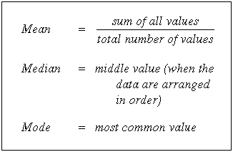3 Median = Mode + 2 Mean. 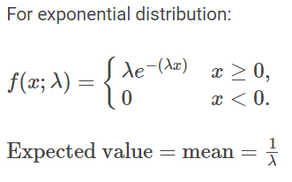

* Standard deviation, variance and coefficient of variation are example of **dispersion measures**. Mean, median and mode are some example of **central tendency measure**.

Useful Link : <https://www.probabilitycourse.com/>

**Summery** :

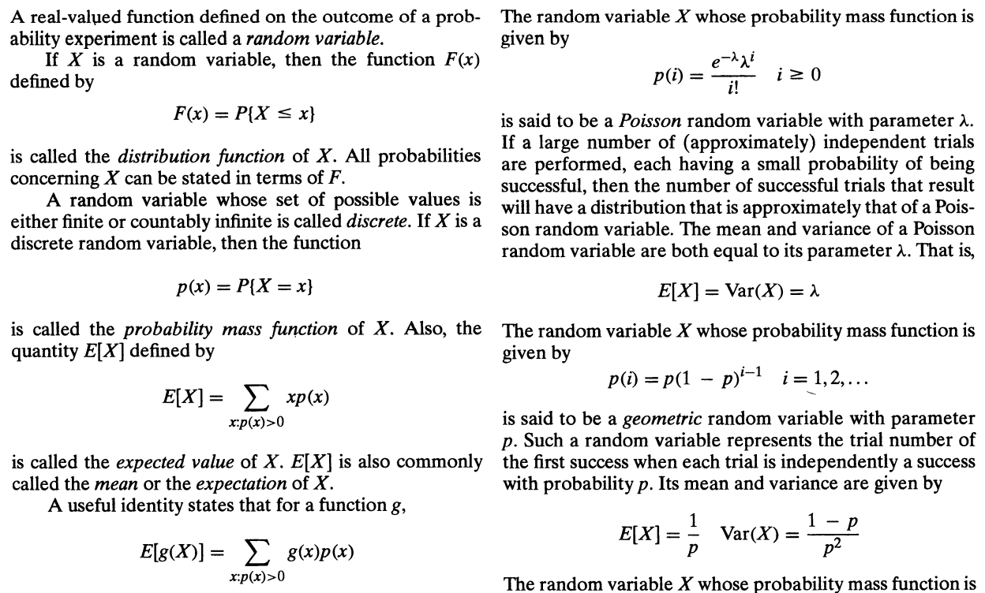

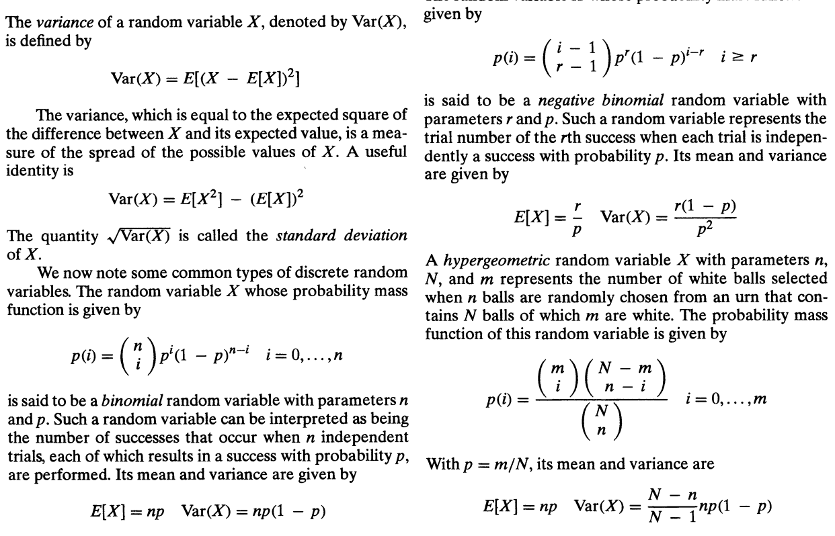

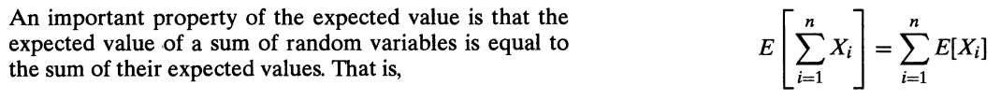

**F(X=a) = P(X=1) + P(X=2) +… +P(X=a)**

**P(A|B) = 1 – P(A’|B)**

**Normal distribution :**

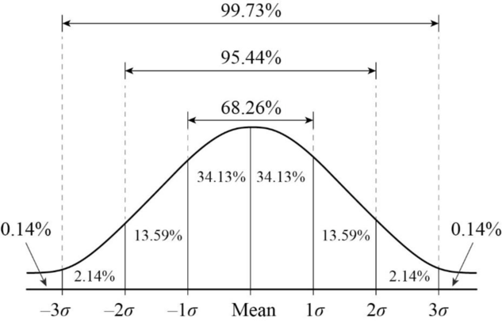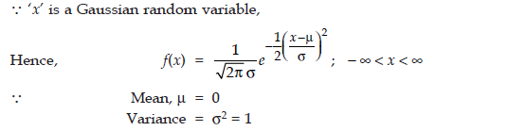

**Geometric distribution :**

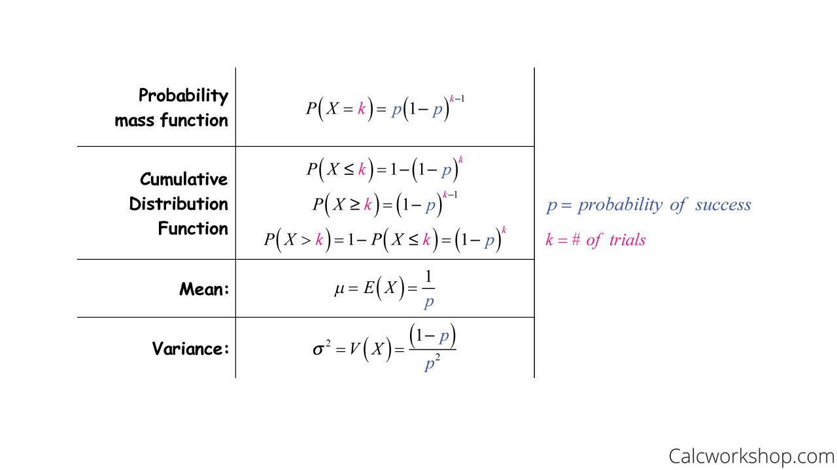

**Exponential distribution :**

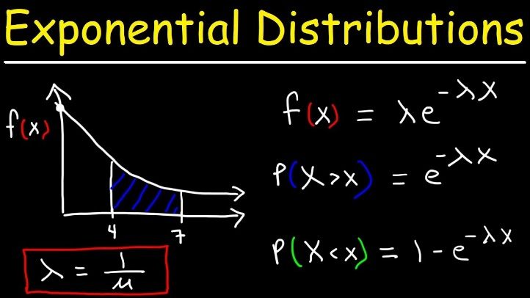

**CALCULUS**

* Continuity :

How to check continuity :

A function f(t) is said to be continuous at a point x = a of its domain if and only if it satisfies the following three conditions :

1. F(a) exists. (“a” lies in the domain of f)
2. Lim x->a f(x) exists i.e. lim x->a+ f(x)= lim x->a- f(x) or RHS = LHS
3. Lim x->a f(x) = f(a) (limit equal the value of function)

Note that here lim x->a+ f(x) = lim h->0 f(a+h) and lim x->a- f(x) = lim h->0 f(a-h)

* Differentiability :

Definition of differentiation is 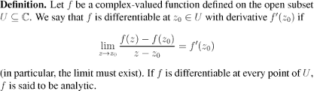

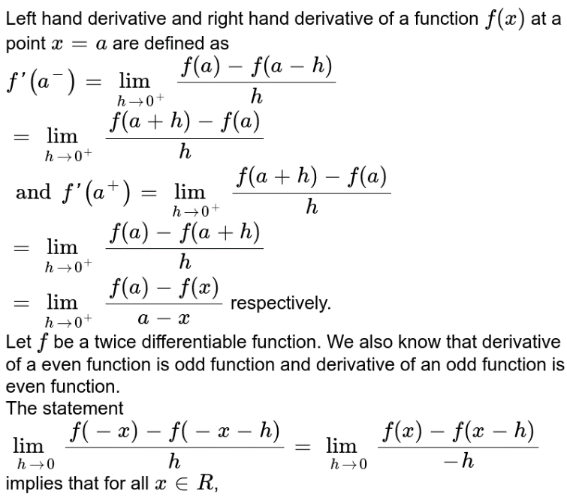 this is called right hand derivative. Replace h by -h and you will get left hand derivative. For differentiability this RHD and LHD should be equal.

**Note** : in above definition value of f(a) is determine by equation which contains = sign. For example consider this

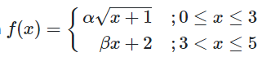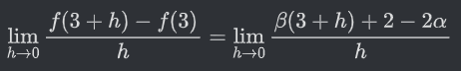 Here f(3) is taken as 2a or 2*alpha and not 3*beta because = signed appears on alpha*sqrt(x+1) i.e. first equation.

1. F(x) = |x-a| is not differentiable at x=a. It is continuous throughout real line R and is differentiable everywhere.

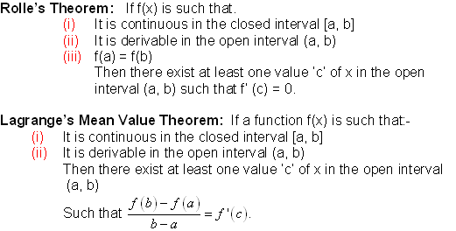

* Maxima and minima :

Take derivative of function and find the value of x. This is trivial now it can be maximum or minimum. So, here comes intuition of second derivative. If the second derivative is positive then the curve is sagging which means value will be minimum. In hogging, curve is cave like shape means it has maximum value at the top you can imagine.

1. Area under the curve approximation :

* Trapezoid Rule :

For this rule we will do the same set up as for the Midpoint Rule. We will break up the interval

[a,b] into n subintervals of width, Δx=(b−a)/n

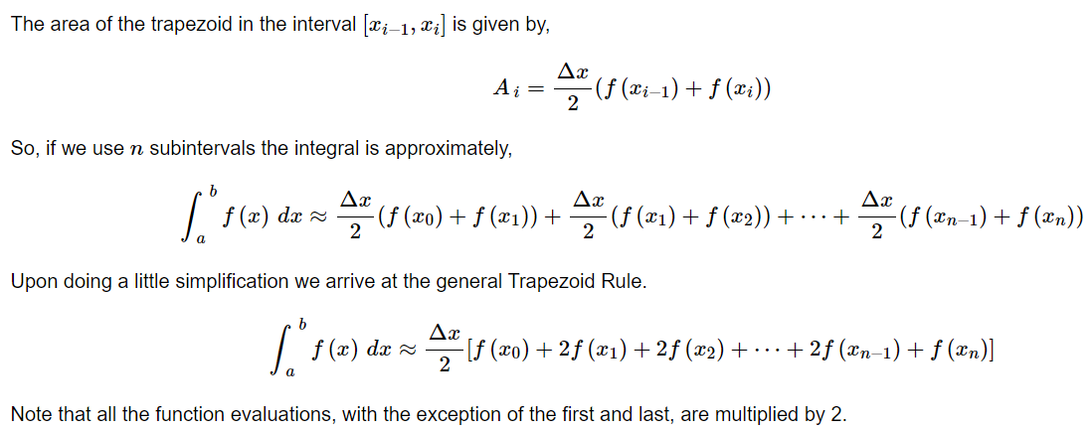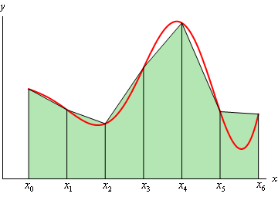

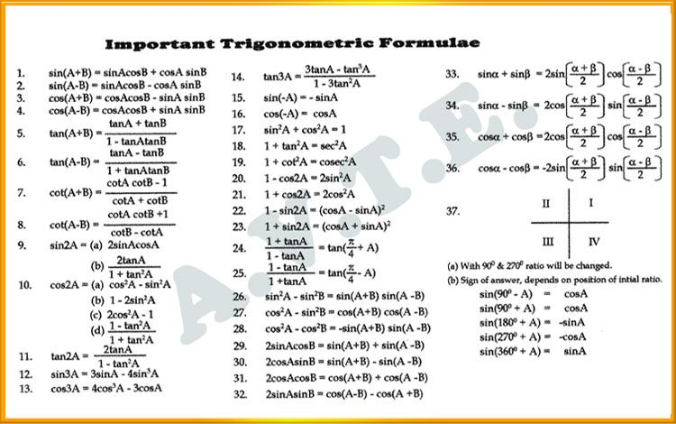

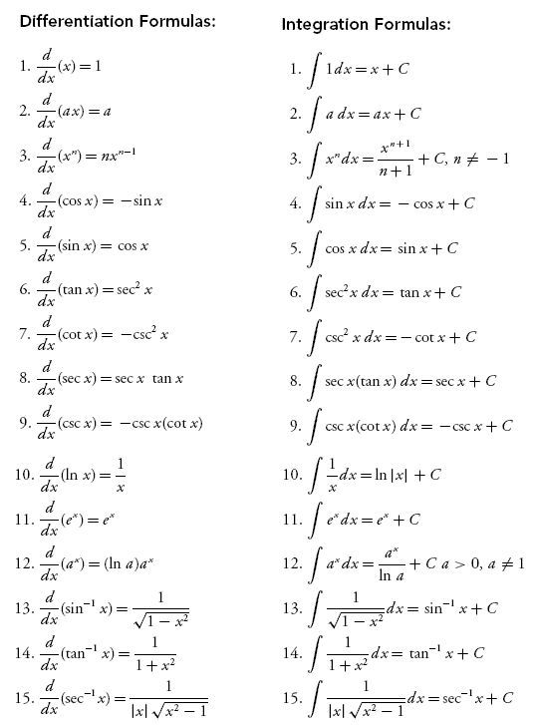 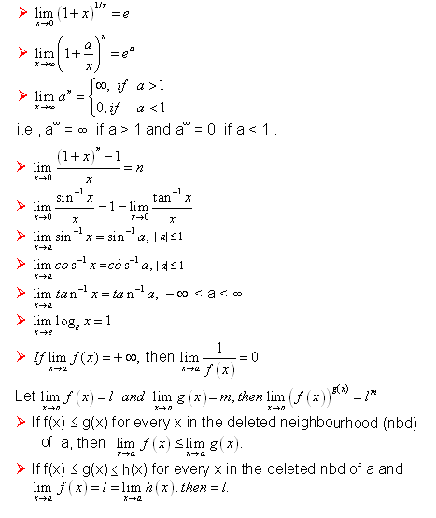

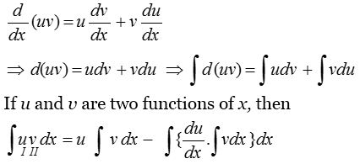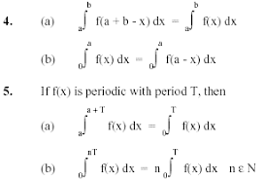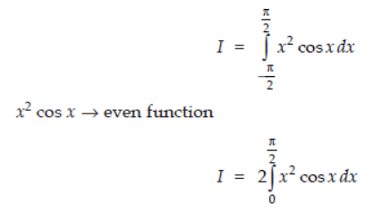

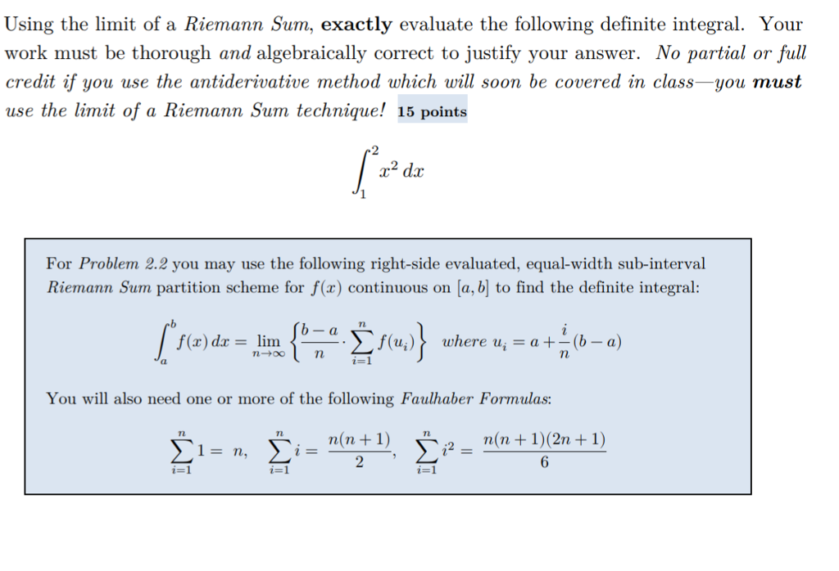

***Questions from Test Series*** :

* **Probability** :

1. The average amount earned by a employee is 2 rupees per day. What is the probability that 3 rupees will be earned tomorrow?

**Answer** :

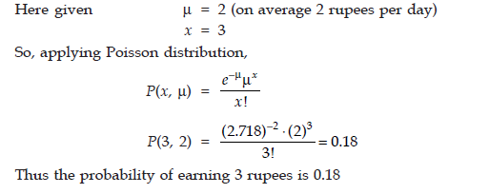

1. A car manufacturing unit produces an average of 12 cars per hour. What is the probability that no car is manufactured in a particular 2hr period ?

**Answer** :

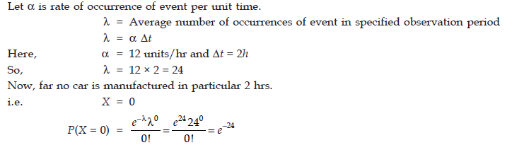

1. Eight players P1​, P2​, ...., P8​ play a knock out tournament. It is known that whenever the players Pi​ and Pj​ play, the player Pi​ will win if i<j. Assuming that the players are paired at random in each round, what is the probability that the player P4​ reaches the final?

**Answer** : read the question twice specially the conditions. Smaller numbered player will win again see the condition.

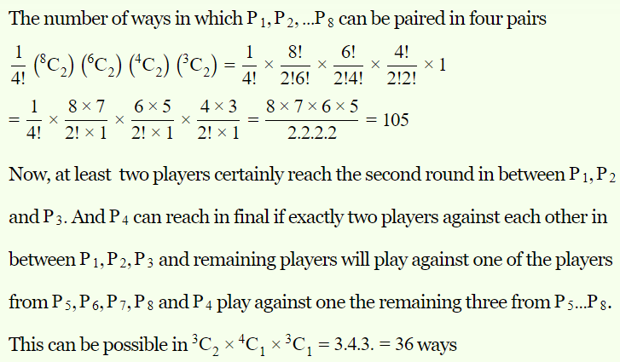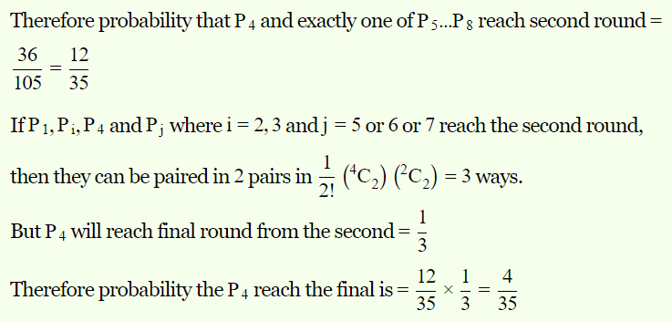

* **Combinatorics** :

1. 

**Answer** : 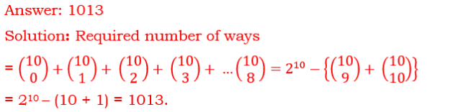 As there are 11 distinct balls. So first we select from 10 balls and there are only one way to select balls from 10 identical balls.

1. By definition, a poker hand is a set of 5 cards from a standard French deck of 52 cards. We shall consider a standard French playing deck, which includes thirteen ranks in each of the four French suits. Thus, each suit will have 13 possible values. A poker hand is said to be a full house if it has three cards with the one value, and two cards with a second value. For instance, three sevens and two Queens, or three Aces and two fives. How many “full house" we can have ?

**Answer** : Very simple, for first number you have 13 choices and you have 4 choices of first number. Out of which you have to select 3 number so 13 * C(4,3). Now for second number you have 12 choices and similarly you have 4 suits so 4 choices for second number out of which you have to select 2 number so, 12 * C(4,2). Now multiply these two cases.

* **Linear Algebra** :



**Answer** : A = B + aI (here alpha is a). you can verify this result. Now let’s x be the eigen vector of B. Ax = Bx + xaI.

Bx = lemda(x)… this is the definition of eigen vector. And let lemda be L

So, Ax = Lx + ax, Ax = (L+a)x, we can say that x is also eigen vector of A as it is also following definition.

L+a = now L have two values given in question i.e. (10 and 0 as being eigen vector of B).

So two eigen vectors of A are 10+a, a. L + u = 24 is also given so we add both 10+2a=24. We get 7 as answer.

**Linear Algebra**

<https://www.csun.edu/~hcmth008/262/review_topics.pdf>

<https://math.oit.edu/~watermang/math_341/341_ch8/F13_341_book_sec_8-4.pdf> 🡸 Column space of A.

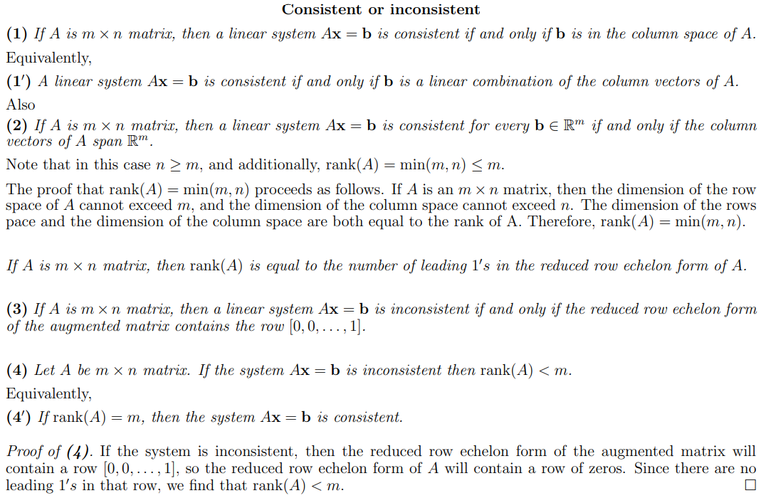

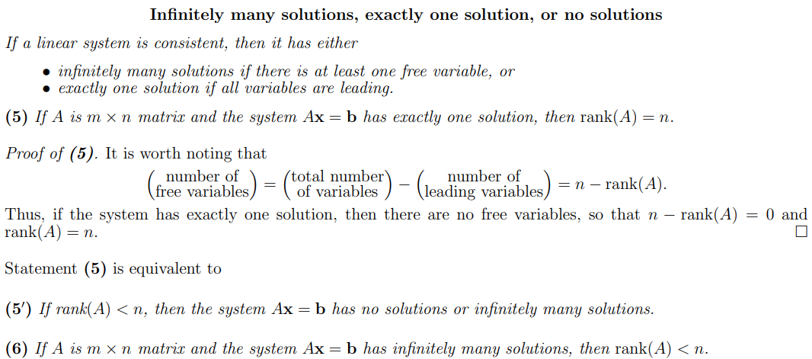

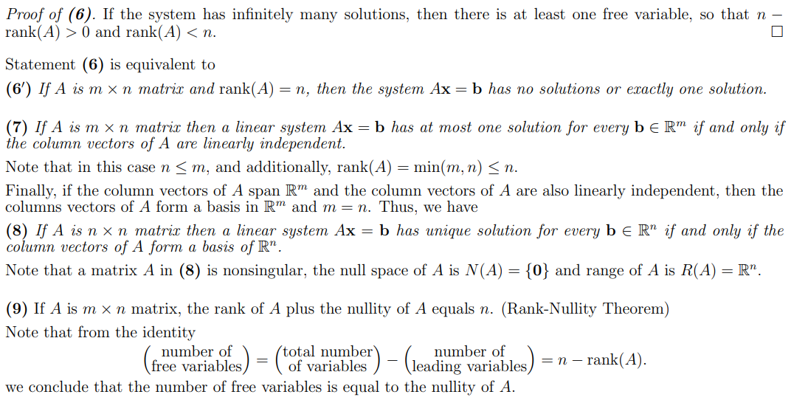

Number of free variables are also called linearly independent solution.

***New notes***

**Introduction :**

1. If a ≅ r mod d (a is congruent to be modulo m it means when we divide a by d we get reminder as r) then a = kd + r and where 0<=r<d and k can be any positive or negative integer.
2. We say that if a ≅ b mod d then d|(a-b) i.e. d divides a-b.
3. a + n ≅ b + a mod d. In general, a + nk ≅ b + nl mod d.
4. Every number is congruent to itself ex. a ≅ a mod d.
5. Every number is congruent to any other number by mod 1. Ex. a ≅ b mod 1.
6. Which one is true ?
7. 7 = 4 mod 3
8. 7 ≅ 4 mod 3 🡨 TRUE
9. Three fundamental rule : if **a ≅ b mod n** and **c ≅ d mod n**
10. a + c ≅ b + d mod n
11. a – c ≅ b-d mod n
12. ac ≅ bd mod n